Specification 33 82 00.00 48
  - Telecommunications Outside Plant (OSP)
Project Name: Anywhere, NC Army Reserve Center
Test Plan Rev. 0
Date: March 1, 2022
Prepared By: The Best Low-Voltage Company, LLC
Reviewed By: Steve Smith, RCDD

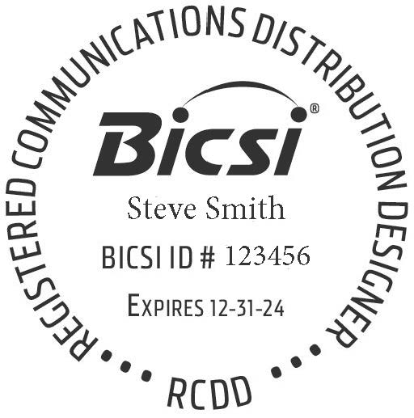

Table of Contents
- Part 1: Testing Objective……………………………………………………………………………………………………………………………………..3
- Part 2: Test Equipment………………………………………………………………………………………………………………………………………..4
- Part 3: Testing Methodology……………………………………………………………………………………………………………………………….5
- Part 4: Test Reports Delivery………………………………………………………………………………………………………………………….……7
- Appendix A: Test Equipment Data Sheets……………………………………………………………………………………………………………8
- Appendix B: Certificates of Calibration……………………………………………………………………………………………………….……..41

Part 1
Testing Objectives
- The objective of this test plan is to document the test equipment, testing methodology, and process for the delivery of the test reports. All testing equipment will be calibrated and recertified no more than 1 year prior to conducting any test. Calibration certificates are provided with this document This test plan has been developed IAW project specifications and ARNEC requirements.

Part 2
Test Equipment
Manufacturer | Model | Serial Number | Calibration Date | Used to Certify
Fluke | DSX-8000 | 12B986YAZ | 3/15/2022 | - Category 6a  - Single-Mode Fiber (Optical Loss)  - Multi-Pair Copper
Fluke | OFP-Quad | 94PT5QN | 1/3/2022 | - Single-Mode Fiber (Optical Time Domain Reflectometer (OTDR))
Fluke | 1623-2 | MUTN4PLK6793 | 2/19/2022 | - Telecommunications Bonding Conductor (Earth-Ground Resistance)  - Telecommunications Bonding Backbone (Earth-Ground Resistance)

Part 3
Testing Methodology
- Visual Inspection.
  - Prior to conducting any testing, all category 6A cabling, multi-pair copper cabling, single mode fiber cabling, and all grounding/bonding components (i.e., busbars, bonding conductors, bonding lugs) will be visually inspected. This visual inspection will include.
    - Cabling and Components will be inspected for any rips, tears, stretch marks, irregular bends, and other deformities.
    - Proper labeling of all cabling and components
    - Proper cable placement, terminations, bonding connections, and required cable slack.
- Failed Test Reports
  - Failed test reports will not be submitted. Any cabling or component that fails any test will have the issue(s) corrected and the testing re-done until a passing test result is obtained.
- Cabling Testing
  - Category 6a Horizontal Cabling
    - Category 6a cabling will be tested with a permanent link test from the termination device in the EF, TER, and TR(s)to each individual modular jack. The performance testing will include the following tests:
    - Wire map.
    - Length (physical vs. electrical, and length requirements).
    - Insertion loss.
    - Near-end crosstalk (NEXT) loss.
    - Power sum near-end crosstalk (PSNEXT) loss.
    - Equal-level far-end crosstalk (ELFEXT).
    - Power sum equal-level far-end crosstalk (PSELFEXT).
    - Return loss.
    - Propagation delay.
    - Delay skew.
  - Multi-Pair Copper Cabling
    - Each pair of multi-pair copper cabling will be tested for wire map and length. The Fluke DSX-8000 1-pair Voice test will be used for this test.
  - Single-Mode Fiber Cabling
    - Each fiber strand will be tested end-to-end, including termination devices, from the fiber patch panel in the TER to the fiber patch panel in the EF and TR(s).
    - All tests will be conducted at the 1310nm and 1550nm wavelengths.
    - A compatible launch cable of 150 meters in length on both fiber ends will be used on all tests.
    - Two separate tests will be conducted on each fiber strand
    - Optical Loss (a.k.a. Power Meter)
      - Three-second auto-test optical loss measurement of each strand of fiber bi-directionally at 1310 and 1550nm wavelengths with distance measurement and optical loss budget calculation
    - OTDR
      - Optical Return Loss (ORL) with graphical view of each fiber strand.
  - Bonding Conductors
    - The earth-ground resistance will be tested for the telecommunications bonding conductor (TBC) and each telecommunications bonding backbone (TBB) in the EF.
    - The 3-pole Fall of Potential method will be used for each bonding conductor tested.
    - A passing test will indicate a resistance of 10 Ohms or less.

Part 4
Test Reports Delivery
- The test reports for this project will be delivered in one consolidated PDF document. Both the summary and detailed test reports will be included for all cables tested.
  - This document will include the following items in the following format.
    - Title Page with low-voltage contractor’s RCDD Stamp (only the title page needs this stamp)
    - Table of Contents. The Table of Contents will indicate the page numbers for each section and will be indexed for ease of use.
    - Separate sections (with header page) for the training building and VMS. Each section will contain
      - Draft as-build floor plans indicating the location and jack label(s) for each telecommunications outlet installed.
      - Category 6a cabling test reports for each horizontal cable terminated in the EF, TER, and TR(s).
      - Multi-pair copper cabling test reposts for each pair terminated in the TER to the EF, and each TR.
      - Single-mode fiber optical loss (power meter) reports for each strand terminated in the TER to the EF, and each TR.
      - Single-mode OTDR test reports for each strand terminated in the TER to the EF, and each TR.
      - Earth-ground resistance test reports for the EF telecommunications bonding conductor and the telecommunications bonding backbone.

Appendix A
Testing Equipment Data Sheets

Appendix B
Certificates of Calibration

